**PROJECT TITLE**

**COMBATIVE DATABASE MANAGEMENT SYSTEM**

**CHAPTER-1**

**INTRODUCTION**

**1.1 Introduction to the title of project**

The management of the army databases can be managed throughout the organisation through divided units of any management and supervisors who have been allotted for the required each system\functions. They have features like information storage, supervision, equipment maintenance and details provided by the soldier databases.

The project has been planned to be having the view of disturbed architecture, with centralized storage of databases. The application for the storage of the data is planned. Using the constructs of MY-SQL Server and all the user interfaces have been designed by using the JAVA-SERVELT (J2EE) technology. The database connectivity is planned using the “SQL-connection” methodology. The standards of security and data protective mechanism has been given a big choice of proper usage. The application takes care of different modules and their associated reports, which are produced as per the applicable strategies and standards that are put forward by the administrative staff

This entire project has been developed keeping in view of the disturbed client server computing technology in mind. The specification has been normalized to 3NF to eliminate all the anomalies that may arise due to database transaction that are executed by the general users and the organizational administration. The user interfaces are browser specific to give distributed accessibility for the overall system. The internal database has been selected as MY-SQL Server. The basic constructs of table specs, clusters and indexes has been exploited to provide higher consistency and reliability for the data storage manages the data consistency with proper business rules or validations. The database connectivity was planned using the latest “SQL-Connection” technology provided by the Microsoft Corporation. The authentication and authorization were crosschecked at all relevant stages. The user level accessibility has been restricted to two zones.

**1.2 Architecture**

The process of constructing each kind of system is not so simple. It involves a mutual development of application program and database. The application program is actually the bridge between the users and the database, where the data is stored. Thus, the well-developed application program and the database are very important for the reliability, flexibility and functionality of the system. The so-defined system differentiates to each other and their development comprises a great variety of tasks to be resolved and implemented. “Organizations depend on information-systems in order to stay competitive. Productivity, which is crucial to staying competitive, can be increased through better information-systems.”

**CHAPTER-2**

**PROBLEM STATEMENT**

**2.1 Problem Discussion**

This report’s documentation goes through the whole process of both application program and database development. It also comprises the development tools which are being utilized for these purposes.

The system should consist of an application program, on one hand, and a database (repository of data) on the other. The program should perform the basic operations upon the database retrieving, inserting, updating and deleting data. Any additional functionality is a goal of further module development. It is a kind of strategy to start the development from designing and constructing the database, as this structure will determine the further structure of the application program. The logical database model (tables, their content and the relationship between them) should respond to the given task and cover the basic requirements. The interface of the program should be user friendly, and the program should be easy to use as if possible. Both controls forms should logically and functionally be related within the program and fully respond to the structure of the database, every time when a query is needed to be performed upon it. Exception-handling should also be taken into an account during the system’s development due to an eventual exception that may occur.

**2.2 Commander Domain Diagram and Analysis**

The commander domain diagram explains how the registration of soldier and commander runs in the real world. After entering into the home page we have two choices, soldier, commander. Soldier can register his details through the registration page. In commander registration page, we have two choices after registering the commander details namely, view and register. If we select the register option, it leads us to register other details like division, barracks and equipments. If we select the view option we can view the details of the soldier with particular ssn.

**2.3 ER-Diagram:**

1 m

ASSIGNS

COMMANDER

DIVISION

1 1

REGISTERED BY

SUPERVISE

m

m

SOLDIER

m 1

EQUIPMENT MAINTAINANCE

ALLOTED

1 1

BARRACKS

EQUIPMENTS

Fig.no-2.3

**2.4 Schema-Diagram:**

COMMANDER

|  |  |  |
| --- | --- | --- |
| c_no | c_name | security_clearence |

DIVISION

|  |  |  |
| --- | --- | --- |
| d_no | d_name | c_no |

SOLDIER

|  |  |  |  |  |  |  |
| --- | --- | --- | --- | --- | --- | --- |
| ssn | s_name | height | weight | c_no | b_name | d_no |

BARRACKS

|  |  |  |
| --- | --- | --- |
| b_name | capacity | size |

EQUIPMENTS

|  |  |
| --- | --- |
| serial_no | type_of_arm |

Fig no-2.4

**2.5 Study of the System**

In the flexibility of the uses the interface has been developed a graphics concept in mind, associated through a browser interface. The GUI’s at the top level have been categorized as

1. Administrative User Interface
2. The Operational / Generic User Interface

The administrative user interface concentrates on the consistent information that is practically, part of the organizational activities and which needs proper authentication for the data collection. The interfaces help the administration with all the transactional states like data insertion, data deletion and data updating along with the extensive data search capabilities.

The Operational / Generic User Interface helps the user upon the system in transactions through the existing data and required services. The Operational User Interface also helps the ordinary users in managing their own information in a customized manner as per the assisted flexibilities

**2.5.1 Number of Modules**

The system after careful analysis has been identidied to be presented with the following modules:

The modules involved are:

Commander

Soldier

Commander:

In this module, , we have two choices after registering the commander details namely, view and register. If we select the register option, it leads us to register other details like division, barracks and equipments. If we select the view option we can view the details of the soldier with particular ssn.

Soldier:

Soldier can register his details through the registration page. The soldier can select barracks, division and equipments details in it. Later the soldier is forwarded to the success page.

**CHAPTER – 3**

**SOFTWARE REQUIREMENTS AND ANALYSIS**

**3.1 Software Requirement Specification**

Operating system: Windows-10

Database Connectivity: MYSQL

Programming Tools: NetBeans 8.2, Eclipse

Server-side Scripting: Java

Front-End Design: HTML

**3.2 Functional Requirements**

User ID is provided with the register. The system must only allow user with valid-ID and password to enter the system. The System performs authorization process which decides what user level can access to. The user must be able to logout after they finish using the system. The system must be able to delete information if it is specified wrong.

**3.3 Software and Hardware Requirements**

**3.3.1 Software Requirements**

Operating System- Windows 10 is used as the operating system as it is stable and supports more features and is friendlier user interface.

Database MYSQL- My SQL is used as the database as it is easy to maintain and retrieve records by simple queries which are in English language which are used to understand and it is also easy to write.

Development Tools and Programming Database- HTML is used to write the whole code and develop web pages with CSS, NetBeans and server side scripting by JAVA.

HTML-5

Hypertext-Mark up language is the standard mark-up language for creating web pages and web applications. With cascading style sheets and java, it forms a triad of cornerstone technologies for the World Wide Web.

APACHE-TOMCAT SERVER

Apache-tomcat server is an open source implementation of Java-Servlet, JavaServer Pages, Java Expressions Language and WebSocket technologies. Tomcat provides a pure-Java HTTP server web environment in which java code can run.

SQL

SQL is a domain-specific language used in programming and designed for managing data held in a relational database management system, or for the stream processing in a relational data stream management system.

ECLIPSE (IDE)

It is an Integrated Development Environment(IDE) used in computer programming. It contains a base workspace and extensible plug-in system for customizing the environment. Eclipse is mostly written in Java and its main purpose is developing java applications, but it may be also used in development of web pages using HTTP.

CASCADING STYLE SHEETS(CSS)

Cascading style sheets is a style sheet language used to describe the presentation of a document written in HTML or XML. It describes how elements should be rendered on screen, on paper, in-speech or other media.

**CHAPTER-4**

**DESIGN**

**4.1 Introduction To Database Design Model**

The database of library system is intended to automate the library activities such as creating new receiver, givers and maintaining the details of all the objects which has been given or taken. This also helps in maintenance of providing category.

A database is an integrated collection of logically related records or files consolidated into a common pool that provides data for one or more multiple uses. One way of classifying databases involves the type of content, for example: Bibliographic, Full-Text, Numeric and others.

Other classification methods start from examining database models or database architectures. The data in database is arranged according to a database model. Relational model is the most common. A database management system(DBMS) consist of software that organizes the storage of the data. A DBMS controls the creation and maintenance and use of the database storage structures of organisations and of their end users. It allows organizations to place control of organization-wide database development in the hands of the Database Administrators(DBA) and other specialists. In large systems, DBMS allows users and other software to store and retrieve data in the structured way. Database management systems are usually categorized according to the database model that they support, such as the network, relational or object model. The model tends to determine the query languages that are available to access the database. One commonly used query for the relational database is SQL, although SQL syntax and function can vary from one DBMS to another. A great deal of the internal engineering of a DBMS is independent of the data model, and is concerned with managing factors such as performance, concurrency, integrity and recovery from hardware failures.

**4.2 Functional Dependencies**

COMMANDER

|  |  |  |
| --- | --- | --- |
| c_no | c_name | security_clearence |

DIVISION

|  |  |  |
| --- | --- | --- |
| d_no | d_name | c_no |

SOLDIER

|  |  |  |  |  |  |  |
| --- | --- | --- | --- | --- | --- | --- |
| ssn | s_name | height | weight | c_no | b_name | d_no |

BARRACKS

|  |  |  |
| --- | --- | --- |
| b_name | capacity | size |

EQUIPMENTS

|  |  |
| --- | --- |
| serial_no | type_of_arm |

Fig no-4.2

**4.3 NORMALIZATION IN SCHEMAS**

·         There are no multivalued attributes in any of the tables so it is in 1NF

·         Every non-prime attribute is fully functionally dependent on the primary key so it

is in 2NF

·         No transitive keys so 3NF

**CHAPTER-5**

**DATABASE AND FRONTEND DESCRIPTION**

**5.1 Database Table Creation**

Here MYSQL is used to create database where the database where the data which is being executed will be stored in that. To create database in MYSQL the query “create database “will be used and that creates a new table. If the database already exists, the query “use database” is used to choose the given the database which already exists

**5.2 Creation Of Tables**

Here first the database is selected and next after the selection, tables are ready to be created. Here we use the query “create table” with the table name specified after that and the other commands are given in brackets and ended with a semicolon.

After pressing enter the table will be created in SQL and to view the tables give the command “desc tables” to view the tables.

To insert the values into the tables use query “insert into table value” to inert the data into the table and to view the data use query “select * from table” and you can view the command.

**5.3 Servlet And MYSQL Connection**

It stands for ‘Java DataBase Connectivity’ adn it is an API(Application Programming Interface) which consists of a set of java classes, interfaces and exceptions and a specification to which both JDBC driver vendors and JDBC developers adhere when developing applications. RDBMS(Relational DataBase Management Systems) or third party vendors develop drivers which adhere to the JDBC specification. Other developers use these drivers to develop applications which access those databases. JDBC driver can access MYSQL. It helps in accessing different RDBMS using different JDBC drivers.

**5.4 Soldier And Commander Features**

**5.4.1 Commander Features**

Commander has features like he can view all the details about any soldier or barracks he is being positioned for the given data and even about the arms and ammunition which is being provided for him and all the other personal information. A commander can access all the information by giving the codename “iloveindia” and if he gives any wrong codename he will not be directed access to the information.

**5.4.2 Soldier Features**

A soldier has features such as he can register or enrol to any prescribed field which he is being specified for it. He can also choose to what field he needs to join and division he wants to join.

**5.5 Front End Design**

Front end is designed using of HTML, Java-Servlet, and CSS

**HTML** – Hyper Text Mark-Up Languages the main mark-up-language for creating web pages and other information that can be displayed in a web browser. HTML is written in form of HTML elements consisting of tags enclosed in angle brackets (<html>) within the web page content. HTML tags commonly come in pairs like <h1> or </h1> , although some tags represent empty elements and so unpaired, for example <img>. The first tag in a pair is the start tag and the second tag is the end tag and in between these tags web designers can add text, further tags, comments and other type of texts based content. The purpose of a web browser is to read HTML documents and compose them into visible or audible web pages. The browser does not display the HTML tags, but uses the tags to interpret the content of the page. HTML elements from building blocks to all websites. HTML allows images and objects embedded and can be used to create interactive forms. It provides a means to create structured documents by denoting structural semantics for text such as headings, paragraphs, lists, links, quotes and other items. It can embed scripts written in languages such as Java-Servlet which effects the behavioural of HTML web pages.

**CSS** **(Cascading Style Sheets)-** is a style sheet used for describing the look and formatting of a document written in mark up language. While most often style used to style web pages and interfaces is written in HTML and XHTML, the language can be applied to any kind of XML document, including the plain XML, SVG and XUL. CSS is a cornerstone specification of the web and almost all web pages uses CSS style sheets to describe the presentation.CSS is designed primarily to enable the document content from the document presentation, including elements such as the layout, colours, and fonts. This separation can improve more content accessibility, more flexibility and control in the specification of presentation characteristics, enable multiple pages to share formatting, and reduce complexity and repetition in the structural content. CSS can also allow the same mark-up page to be presented in different styles for different rendering methods, such as on-screen, in-print, by-voice and on Braille-based tactile devices.

**Java-Servlet-** is a java software component that extends the capabilities of server. Although servlet can respond to many types of requests, they most commonly implement web containers for hosting web applications on web servers and thus qualify as a server-side servlet web-API. Such web servlets are the java counterpart to other dynamic web content technologies such as PHP and ASP.NET.

**5.6 Back-End Design**

**MYSQL-** Is an open-source relational database management system. Its name is a combination of “My”, the name of co-founder is Michael-Widenius’s daughter and MYSQL full form is Structured Query Language. It is a multithreaded, multiuser, SQL data management system. The project source code is available under the terms of GNU(General Public License) as well as under a variety of property arguments. A table collection of related data entries and it consists of columns and rows. The databases are useful when storing information categorically.

**JDBC-** It stands for ‘Java DataBase Connectivity’ adn it is an API(Application Programming Interface) which consists of a set of java classes, interfaces and exceptions and a specification to which both JDBC driver vendors and JDBC developers adhere when developing applications. RDBMS(Relational DataBase Management Systems) or third party vendors develop drivers which adhere to the JDBC specification. Other developers use these drivers to develop applications which access those databases. JDBC driver can access MYSQL. It helps in accessing different RDBMS using different JDBC drivers.

**5.7 Programming language selection**

Java Servlet is a java software component that extends the capabilities of server. Although servlet can respond to many types of requests, they most commonly implement web containers for hosting web applications on web servers and thus qualify as a server-side servlet web-API. Such web servlets are the java counterpart to other dynamic web content technologies such as PHP and ASP.NET.

SQL is a domain-specific language used in programming and designed for managing data held in a relational database management system, or for the stream processing in a relational data stream management system.

**5.7.1 Sample Coding:**

1. **Home.html**

<!DOCTYPE html>

<html>

<head>

<meta charset=*"ISO-8859-1"*>

<title>Insert title here</title>

</head>

<body>

<img src=*"images/commander5.jpeg"* style="z-index:*-1*;position:*fixed*;width:*100%*;height:*100%*"/>

<h1><b><center><font size=*7* color=*black*>COMMANDER REGISTRATION</font></center></b><br></h1>

<form action=*"Commander"* method=*"post"*><br><br><br>

<font size=*6* color=*black*>COMMANDER NUMBER:<input type=*'text'* name=*'c_no'*/></font><br><br><br>

<font size=*6* color=*black*>COMMANDER NAME:<input type=*'text'* name=*'c_name'*/></font><br><br><br>

<font size=*6* color=*black*>SECURITY CLEARENCE:<input type=*'text'* name=*'security_clearence'*/></font><br><br><br>

<input type=*'submit'* value=*'ENTER'*/><br><br>

<font size=*6* color=*black*><a href=*"VisionForm.html"*> VIEW </a><br></font>

<br><br><br><br><br><br><br><br>

<blockquote><footer><i><center><font size=*7* color=*black*>"Toleration and liberty are the foundations of a great republic."

</font></center></i></footer></blockquote>

</form>

</body>

</html>

1. **CommanderForm.html**

<!DOCTYPE html>

<html>

<head>

<meta charset=*"ISO-8859-1"*>

<title>Insert title here</title>

</head>

<body>

<img src=*"images/commander5.jpeg"* style="z-index:*-1*;position:*fixed*;width:*100%*;height:*100%*"/>

<h1><b><center><font size=*7* color=*black*>COMMANDER REGISTRATION</font></center></b><br></h1>

<form action=*"Commander"* method=*"post"*><br><br><br>

<font size=*6* color=*black*>COMMANDER NUMBER:<input type=*'text'* name=*'c_no'*/></font><br><br><br>

<font size=*6* color=*black*>COMMANDER NAME:<input type=*'text'* name=*'c_name'*/></font><br><br><br>

<font size=*6* color=*black*>SECURITY CLEARENCE:<input type=*'text'* name=*'security_clearence'*/></font><br><br><br>

<input type=*'submit'* value=*'ENTER'*/><br><br>

<font size=*6* color=*black*><a href=*"VisionForm.html"*> VIEW </a><br></font>

<br><br><br><br><br><br><br><br>

<blockquote><footer><i><center><font size=*7* color=*black*>"Toleration and liberty are the foundations of a great republic."

</font></center></i></footer></blockquote>

</form>

</body>

</html>

1. **DivisionForm.html**

<!DOCTYPE html>

<html>

<head>

<meta charset=*"ISO-8859-1"*>

<title>Insert title here</title>

</head>

<body>

<img src=*"images/division6.jpg"* style="z-index:*-1*;position:*fixed*;width:*100%*;height:*100%*"/>

<h1><b><center><font size=*7* color=*black*>DIVISION REGISTRATION</font></center></b><br></h1>

<form action=*"Division"* method=*"post"*><br><br><br>

<font size=*6* color=*black*>DIVISION NUMBER:<input type=*'text'* name=*'d_no'*/></font><br><br><br><br>

<font size=*6* color=*black*>DIVISION NAME:<input type=*'text'* name=*'d_name'*/></font><br><br><br><br>

<input type=*'submit'* value=*'ENTER'*/><br><br><br>

<br><br><br><br><br><br><br><br><br>

<blockquote><footer><i><center><font size=*7* color=*black*>"The patriot volunteer, fighting for country and his rights, makes the most reliable soldier on earth."

</font></center></i></footer></blockquote>

</form>

</body>

</html>

1. **BarracksForm.html**

<!DOCTYPE html>

<html>

<head>

<meta charset=*"ISO-8859-1"*>

<title>Insert title here</title>

</head>

<body>

<img src=*"images/barracks5.jpg"* style="z-index:*-1*;position:*fixed*;width:*100%*;height:*100%*"/>

<h1><b><center><font size=*7* color=*black*>REGISTRATION PAGE</font></center></b><br></h1>

<form action=*"Barracks"* method=*"post"*><br><br><br>

<font size=*6* color=*black*>Barrack Name:<input type=*'text'* name=*'b_name'*/></font><br><br><br>

<font size=*6* color=*black*>Capacity:<input type=*'text'* name=*'capacity'*/></font><br><br><br>

<font size=*6* color=*black*>Size:<input type=*'text'* name=*'size'*/><br><br></font>

<font size=*6* color=*black*><input type=*'submit'* value=*'ENTER'*/>

<br><br><br><br><br>

<blockquote><footer><i><center><font size=*7* color=*black*>"The tree of liberty must be refreshed from time to time with the blood of patriots and tyrants."

</font></center></i></footer></blockquote>

</form>

</body>

</html>

1. **EquipmentsForm.html**

<!DOCTYPE html>

<html>

<head>

<meta charset=*"ISO-8859-1"*>

<title>Insert title here</title>

</head>

<body>

<img src=*"images/equipments4.jpg"* style="z-index:*-1*;position:*fixed*;width:*100%*;height:*100%*"/>

<h1><b><center><font size=*7* color=*white*>EQUIPMENTS REGISTRATION</font></center></b></h1><br>

<form action=*"Equipments"* method=*"post"*><br><br>

<font size=*6* color=*white*>SERIAL NUMBER OF THE EQUIPMENT:<input type=*'text'* name=*'serial_no'*/></font><br><br><br><br>

<font size=*6* color=*white*>TYPE OF EQUIPMENT:<input type=*'text'* name=*'type_of_arm'*/></font><br><br><br><br>

<input type=*'submit'* value=*'ENTER'*/>

<br><br><br><br><br><br><br><br><br><br><br><br><br><br>

<blockquote><footer><i><center><font size=*7* color=*white*>"Wars may be fought with weapons, but they are won by men. It is the spirit of men who follow and of the man who leads that gains the victory."

</font></center></i></footer></blockquote>

</form>

</body>

</html>

1. **VisionForm.html**

<!DOCTYPE html>

<html>

<head>

<meta charset=*"ISO-8859-1"*>

<title>Insert title here</title>

</head>

<body>

<img src=*"images/soldier6.jpeg"* style="z-index:*-1*;position:*fixed*;width:*100%*;height:*100%*"/>

<h1><b><center><font size=*7* color=*white*>VISION</font></center></h1><br><br>

<form action=*"Vision"* method=*"post"*><br><br>

<font size=*6* color=*white*>SELECT SOLDIER SSN :<input type=*'text'* name=*'ssn'*/></font><br><br>

<input type=*'submit'* value=*'SELECT'*/>

<br><br><br><br><br><br><br><br><br><br><br><br><br><br><br><br><br><br><br><br><br>

<blockquote><footer><i><center><font size=*7* color=*white*>"Quartered in snow, silent to remain. When the bugle calls, they shall rise and march again."

</font></center></i></footer></blockquote>

</form>

</body>

</html>

1. **SoldierForm.html**

<!DOCTYPE html>

<html>

<head>

<meta charset=*"ISO-8859-1"*>

<title>Insert title here</title>

</head>

<body>

<font size=*7* color=*white*><img src=*"images/registration2.jpg"* style="z-index:*-1*;position:*fixed*;width:*100%*;height:*100%*"/> </font>

<h1><b><center><font size=*7* color=*white*>REGISTRATION PAGE</font></center></b><br><br></h1>

<a href=*"Soldier"*><font size=*7* color=*white*>REGISTER</font></a>

<br><br><br><br><br><br><br><br><br><br><br><br><br><br><br><br><br><br><br><br><br><br>

<blockquote><footer><i><center><font size=*7* color=*white*>"A Country's greatness lies in its undying ideals of love and sacrifice that inspire the mothers of the race."

</font></center></i></footer></blockquote>

</body>

</html>

1. **Commander.java**

**package** com.test;

**import** java.io.IOException;

**import** java.io.PrintWriter;

**import** java.sql.Connection;

**import** java.sql.DriverManager;

**import** java.sql.PreparedStatement;

**import** javax.servlet.RequestDispatcher;

**import** javax.servlet.ServletException;

**import** javax.servlet.annotation.WebServlet;

**import** javax.servlet.http.HttpServlet;

**import** javax.servlet.http.HttpServletRequest;

**import** javax.servlet.http.HttpServletResponse;

/**

* Servlet implementation class Commander

*/

@WebServlet("/Commander")

**public** **class** Commander **extends** HttpServlet {

**private** **static** **final** **long** ***serialVersionUID*** = 1L;

/**

* **@see** HttpServlet#HttpServlet()

*/

**public** Commander() {

**super**();

// **TODO** Auto-generated constructor stub

}

/**

* **@see** HttpServlet#doGet(HttpServletRequest request, HttpServletResponse response)

*/

**protected** **void** doGet(HttpServletRequest request, HttpServletResponse response) **throws** ServletException, IOException {

// **TODO** Auto-generated method stub

response.getWriter().append("Served at: ").append(request.getContextPath());

}

/**

* **@see** HttpServlet#doPost(HttpServletRequest request, HttpServletResponse response)

*/

**protected** **void** doPost(HttpServletRequest request, HttpServletResponse response) **throws** ServletException, IOException {

**try** {

String code="iloveindia";

response.setContentType("text/html");

PrintWriter out = response.getWriter();

**int** a=Integer.*parseInt*(request.getParameter("c_no"));

String b=request.getParameter("c_name");

String c=request.getParameter("security_clearence");

Class.*forName*("com.mysql.jdbc.Driver");

Connection con=DriverManager.*getConnection*(

"jdbc:mysql://localhost:3306/project","root","root");

PreparedStatement ps=con.prepareStatement("insert into commander values(?,?,?)");

ps.setInt(1,a);

ps.setString(2,b);

ps.setString(3,c);

**int** i=ps.executeUpdate();

**if**(c.equals(code))

{

RequestDispatcher rd = request.getRequestDispatcher("DivisionForm.html");

rd.forward(request, response);

}

**else**

{

RequestDispatcher rd = request.getRequestDispatcher("Home.html");

rd.forward(request, response);

}

out.close();

}**catch** (Exception e2) {System.***out***.println(e2);}

}

}

1. **Division.java**

**package** com.test;

**import** java.io.IOException;

**import** java.io.PrintWriter;

**import** java.sql.Connection;

**import** java.sql.DriverManager;

**import** java.sql.PreparedStatement;

**import** javax.servlet.RequestDispatcher;

**import** javax.servlet.ServletException;

**import** javax.servlet.annotation.WebServlet;

**import** javax.servlet.http.HttpServlet;

**import** javax.servlet.http.HttpServletRequest;

**import** javax.servlet.http.HttpServletResponse;

/**

* Servlet implementation class Division

*/

@WebServlet("/Division")

**public** **class** Division **extends** HttpServlet {

**private** **static** **final** **long** ***serialVersionUID*** = 1L;

/**

* **@see** HttpServlet#HttpServlet()

*/

**public** Division() {

**super**();

// **TODO** Auto-generated constructor stub

}

/**

* **@see** HttpServlet#doGet(HttpServletRequest request, HttpServletResponse response)

*/

**protected** **void** doGet(HttpServletRequest request, HttpServletResponse response) **throws** ServletException, IOException {

// **TODO** Auto-generated method stub

response.getWriter().append("Served at: ").append(request.getContextPath());

}

/**

* **@see** HttpServlet#doPost(HttpServletRequest request, HttpServletResponse response)

*/

**protected** **void** doPost(HttpServletRequest request, HttpServletResponse response) **throws** ServletException, IOException {

**try** {

response.setContentType("text/html");

PrintWriter out = response.getWriter();

**int** a=Integer.*parseInt*(request.getParameter("d_no"));

String b=request.getParameter("d_name");

Class.*forName*("com.mysql.jdbc.Driver");

Connection con=DriverManager.*getConnection*(

"jdbc:mysql://localhost:3306/project","root","root");

PreparedStatement ps=con.prepareStatement(

"insert into division values(?,?)");

ps.setInt(1,a);

ps.setString(2,b);

**int** i=ps.executeUpdate();

RequestDispatcher rd = request.getRequestDispatcher("BarracksForm.html");

rd.forward(request, response);

out.close();

}**catch** (Exception e2) {System.***out***.println(e2);}

}

}

1. **Barracks.java**

package com.test;

import java.io.IOException;

import java.io.PrintWriter;

import java.sql.Connection;

import java.sql.DriverManager;

import java.sql.PreparedStatement;

import javax.servlet.RequestDispatcher;

import javax.servlet.ServletException;

import javax.servlet.annotation.WebServlet;

import javax.servlet.http.HttpServlet;

import javax.servlet.http.HttpServletRequest;

import javax.servlet.http.HttpServletResponse;

/**

* Servlet implementation class Barracks

*/

@WebServlet("/Barracks")

public class Barracks extends HttpServlet {

private static final long serialVersionUID = 1L;

/**

* @see HttpServlet#HttpServlet()

*/

public Barracks() {

super();

// TODO Auto-generated constructor stub

}

/**

* @see HttpServlet#doGet(HttpServletRequest request, HttpServletResponse response)

*/

protected void doGet(HttpServletRequest request, HttpServletResponse response) throws ServletException, IOException {

// TODO Auto-generated method stub

response.getWriter().append("Served at: ").append(request.getContextPath());

}

/**

* @see HttpServlet#doPost(HttpServletRequest request, HttpServletResponse response)

*/

protected void doPost(HttpServletRequest request, HttpServletResponse response) throws ServletException, IOException {

try {

response.setContentType("text/html");

PrintWriter out = response.getWriter();

String a=request.getParameter("b_name");

int b=Integer.parseInt(request.getParameter("capacity"));

int c=Integer.parseInt(request.getParameter("size"));

Class.forName("com.mysql.jdbc.Driver");

Connection con=DriverManager.getConnection(

"jdbc:mysql://localhost:3306/project","root","root");

PreparedStatement ps=con.prepareStatement(

"insert into barracks values(?,?,?)");

ps.setString(1,a);

ps.setInt(2,b);

ps.setInt(3,c);

int i=ps.executeUpdate();

RequestDispatcher rd = request.getRequestDispatcher("EquipmentsForm.html");

rd.forward(request, response);

out.close();

}catch (Exception e2) {System.out.println(e2);}

}

}

1. **Equipments.java**

package com.test;

import java.io.IOException;

import java.io.PrintWriter;

import java.sql.Connection;

import java.sql.DriverManager;

import java.sql.PreparedStatement;

import javax.servlet.RequestDispatcher;

import javax.servlet.ServletException;

import javax.servlet.annotation.WebServlet;

import javax.servlet.http.HttpServlet;

import javax.servlet.http.HttpServletRequest;

import javax.servlet.http.HttpServletResponse;

/**

* Servlet implementation class Equipments

*/

@WebServlet("/Equipments")

public class Equipments extends HttpServlet {

private static final long serialVersionUID = 1L;

/**

* @see HttpServlet#HttpServlet()

*/

public Equipments() {

super();

// TODO Auto-generated constructor stub

}

/**

* @see HttpServlet#doGet(HttpServletRequest request, HttpServletResponse response)

*/

protected void doGet(HttpServletRequest request, HttpServletResponse response) throws ServletException, IOException {

// TODO Auto-generated method stub

response.getWriter().append("Served at: ").append(request.getContextPath());

}

/**

* @see HttpServlet#doPost(HttpServletRequest request, HttpServletResponse response)

*/

protected void doPost(HttpServletRequest request, HttpServletResponse response) throws ServletException, IOException {

try {

response.setContentType("text/html");

PrintWriter out = response.getWriter();

int a=Integer.parseInt(request.getParameter("serial_no"));

String b=request.getParameter("type_of_arm");

Class.forName("com.mysql.jdbc.Driver");

Connection con=DriverManager.getConnection(

"jdbc:mysql://localhost:3306/project","root","root");

PreparedStatement ps=con.prepareStatement(

"insert into equipments values(?,?)");

ps.setInt(1,a);

ps.setString(2,b);

int i=ps.executeUpdate();

RequestDispatcher rd = request.getRequestDispatcher("Home.html");

rd.forward(request, response);

out.close();

}catch (Exception e2) {System.out.println(e2);}

}

}

1. **Vision.java**

package com.test;

import java.io.IOException;

import java.io.PrintWriter;

import java.sql.Connection;

import java.sql.DriverManager;

import java.sql.PreparedStatement;

import java.sql.ResultSet;

import java.sql.Statement;

import javax.servlet.RequestDispatcher;

import javax.servlet.ServletException;

import javax.servlet.annotation.WebServlet;

import javax.servlet.http.HttpServlet;

import javax.servlet.http.HttpServletRequest;

import javax.servlet.http.HttpServletResponse;

/**

* Servlet implementation class Vision

*/

@WebServlet("/Vision")

public class Vision extends HttpServlet {

private static final long serialVersionUID = 1L;

/**

* @see HttpServlet#HttpServlet()

*/

public Vision() {

super();

// TODO Auto-generated constructor stub

}

/**

* @see HttpServlet#doGet(HttpServletRequest request, HttpServletResponse response)

*/

protected void doGet(HttpServletRequest request, HttpServletResponse response) throws ServletException, IOException {

// TODO Auto-generated method stub

response.getWriter().append("Served at: ").append(request.getContextPath());

}

/**

* @see HttpServlet#doPost(HttpServletRequest request, HttpServletResponse response)

*/

protected void doPost(HttpServletRequest request, HttpServletResponse response) throws ServletException, IOException {

// TODO Auto-generated method stub

try

{

response.setContentType("text/html");

PrintWriter out = response.getWriter();

Class.forName("com.mysql.jdbc.Driver");

Connection con=DriverManager.getConnection(

"jdbc:mysql://localhost:3306/project","root","root");

int a=Integer.parseInt(request.getParameter("ssn"));

PreparedStatement ps=con.prepareStatement("select * from soldier where ssn=?");

ps.setInt(1,a);

ResultSet rs=ps.executeQuery();

while(rs.next())

{

out.println("<html>"

+"<img src='images/details2.jpg' style='z-index:-1;position:fixed;width:100%;height:100%'/>"

+" <h1><b><center><font size=7 color=white>SOLDIER DETAILS</font></center></h1><br><br><font size=6 color=white>SOLDIER SSN= ");

out.println(rs.getInt(1)+"<br>SOLDIER NAME= "+rs.getString(2)+"<br> HEIGHT= "+rs.getInt(3)+"<br>WEIGHT= "+rs.getInt(4)+"<br>DIVISION NUMBER= "+rs.getInt(5)+"<br>DIVISION NAME= "+rs.getString(6)+"<br>BARRACK NAME= "+rs.getString(7)+"<br>BARRACK CAPACITY= "+rs.getInt(8)+"<br>BARRACK SIZE= "+rs.getInt(9)+" <br>EOUIPMENT NUMBER= "+rs.getInt(10)+" <br>TYPE OF EQUIPMENT= "+rs.getString(11));

out.println("<br><form method=post action=Home.html></font>"

+ "<input type=submit name=submit value=Back></form>"

+"<br><br><blockquote><footer><i><center><font size=7 color=white>\"A man's feet should be planted in his country, but his eyes should survey the world.\r\n" +

"\"\r\n" +

"</font></center></i></footer></blockquote>"

+ "</html>");

}

}

catch(Exception e)

{

e.printStackTrace();

}

}

}

1. **Soldier.java**

package com.test;

import java.io.IOException;

import java.io.PrintWriter;

import java.sql.Connection;

import java.sql.DriverManager;

import java.sql.ResultSet;

import java.sql.Statement;

import javax.servlet.ServletException;

import javax.servlet.annotation.WebServlet;

import javax.servlet.http.HttpServlet;

import javax.servlet.http.HttpServletRequest;

import javax.servlet.http.HttpServletResponse;

/**

* Servlet implementation class Soldier

*/

@WebServlet("/Soldier")

public class Soldier extends HttpServlet {

private static final long serialVersionUID = 1L;

/**

* @see HttpServlet#HttpServlet()

*/

public Soldier() {

super();

// TODO Auto-generated constructor stub

}

/**

* @see HttpServlet#doGet(HttpServletRequest request, HttpServletResponse response)

*/

protected void doGet(HttpServletRequest request, HttpServletResponse response) throws ServletException, IOException

{

response.setContentType("text/html");

PrintWriter ps = response.getWriter();

try

{

Class.forName("com.mysql.jdbc.Driver");

Connection con = DriverManager.getConnection("jdbc:mysql://localhost:3306/project", "root", "root");

String sql ="select * from division";

Statement st = con.createStatement();

ps.println("<html>"

+ "<img src=\"images/selectssn4.jpg\" style=\"z-index:-1;position:fixed;width:100%;height:100%\"/>"

+" <h1><b><center><font size=7 color=white>SOLDIER REGISTRATION</font></center></b><br></h1>");

ps.println("<form method=post action=storeData>"

+

"<font size=6 color=white>SSN:<input type='text' name='ssn'/>\r\n" +

"<font size=6 color=white>SOLDIER NAME:<input type='text' name='s_name'/>\r\n" +

"<font size=6 color=white>HEIGHT:<input type='text' name='height'/>\r\n" +

"<font size=6 color=white>WEIGHT:<input type='text' name='weight'/></font><br>"

+ ""

+ "<h1><font size=6 color=white>Division Number</h1><select name=choice0></font>");

ResultSet rs = st.executeQuery(sql);

while(rs.next())

{

ps.print("<option>"+rs.getInt(1)+"</option>");

}

ps.println("</select>");

String sql1 ="select * from division";

Statement st1 = con.createStatement();

ps.println("<h1><font size=6 color=white>Division Name</h1><select name=choice1></font>");

ResultSet rs1 = st1.executeQuery(sql1);

while(rs1.next())

{

ps.print("<option>"+rs1.getString(2)+"</option>");

}

ps.println("</select>");

String sql2 ="select * from barracks";

Statement st2 = con.createStatement();

ps.println("<h1><font size=6 color=white>Barrack Name</h1><select name=choice2></font>");

ResultSet rs2 = st2.executeQuery(sql2);

while(rs2.next())

{

ps.print("<option>"+rs2.getString(1)+"</option>");

}

ps.println("</select>");

String sql3 ="select * from barracks";

Statement st3 = con.createStatement();

ps.println("<h1><font size=6 color=white>Barrack Capacity</h1><select name=choice3></font>");

ResultSet rs3 = st3.executeQuery(sql3);

while(rs3.next())

{

ps.print("<option>"+rs3.getInt(2)+"</option>");

}

ps.println("</select>");

String sql4 ="select * from barracks";

Statement st4 = con.createStatement();

ps.println("<h1><font size=6 color=white>Barrack Size</h1><select name=choice4></font>");

ResultSet rs4 = st4.executeQuery(sql4);

while(rs4.next())

{

ps.print("<option>"+rs4.getString(3)+"</option>");

}

ps.println("</select>");

String sql5 ="select * from equipments";

Statement st5 = con.createStatement();

ps.println("<h1><font size=6 color=white>Equipment Number </h1><select name=choice5></font>");

ResultSet rs5 = st5.executeQuery(sql5);

while(rs5.next())

{

ps.print("<option>"+rs5.getInt(1)+"</option>");

}

ps.println("</select>");

String sql6 ="select * from equipments";

Statement st6 = con.createStatement();

ps.println("<h1><font size=6 color=white>Type Of Arm</h1><select name=choice6></font>");

ResultSet rs6 = st6.executeQuery(sql6);

while(rs6.next())

{

ps.print("<option>"+rs6.getString(2)+"</option>");

}

ps.println("</select><br><br><input type=submit name=submit value=Register></form></html>");

}

catch(Exception e)

{

e.printStackTrace();

}

}

}

1. **storeData.java**

package com.test;

import java.io.IOException;

import java.io.PrintWriter;

import java.sql.Connection;

import java.sql.DriverManager;

import java.sql.PreparedStatement;

import java.sql.SQLException;

import javax.servlet.ServletException;

import javax.servlet.annotation.WebServlet;

import javax.servlet.http.HttpServlet;

import javax.servlet.http.HttpServletRequest;

import javax.servlet.http.HttpServletResponse;

/**

* Servlet implementation class storeData

*/

@WebServlet("/storeData")

public class storeData extends HttpServlet {

private static final long serialVersionUID = 1L;

/**

* @see HttpServlet#HttpServlet()

*/

public storeData() {

super();

// TODO Auto-generated constructor stub

}

/**

* @see HttpServlet#doGet(HttpServletRequest request, HttpServletResponse response)

*/

protected void doGet(HttpServletRequest request, HttpServletResponse response) throws ServletException, IOException {

// TODO Auto-generated method stub

response.getWriter().append("Served at: ").append(request.getContextPath());

}

/**

* @see HttpServlet#doPost(HttpServletRequest request, HttpServletResponse response)

*/

protected void doPost(HttpServletRequest request, HttpServletResponse response) throws ServletException, IOException {

try {

response.setContentType("text/html");

PrintWriter out = response.getWriter();

int m=Integer.parseInt(request.getParameter("ssn"));

String n=request.getParameter("s_name");

int o=Integer.parseInt(request.getParameter("height"));

int p=Integer.parseInt(request.getParameter("weight"));

int q=Integer.parseInt(request.getParameter("choice0"));

String r=request.getParameter("choice1");

String s=request.getParameter("choice2");

int t=Integer.parseInt(request.getParameter("choice3"));

int u=Integer.parseInt(request.getParameter("choice4"));

int v=Integer.parseInt(request.getParameter("choice5"));

String w=request.getParameter("choice6");

Class.forName("com.mysql.jdbc.Driver");

Connection con=DriverManager.getConnection(

"jdbc:mysql://localhost:3306/project","root","root");

PreparedStatement ps=con.prepareStatement(

"insert into soldier values(?,?,?,?,?,?,?,?,?,?,?)");

ps.setInt(1,m);

ps.setString(2,n);

ps.setInt(3,o);

ps.setInt(4,p);

ps.setInt(5,q);

ps.setString(6,r);

ps.setString(7,s);

ps.setInt(8,t);

ps.setInt(9,u);

ps.setInt(10,v);

ps.setString(11,w);

int i=ps.executeUpdate();

if(i>0)

{

out.println("<html>"

+ "<img src=\"images/success.jpg\" style=\"z-index:-1;position:fixed;width:100%;height:100%\"/>"

+" <h1><b><center><font size=7 color=black>SUCCESS PAGE</font></center></h1><br><br>");

out.println("<font size=6 color=white>Successfully Registered</font><br><br><br><br>");

out.println("<html><form method=post action=Home.html>"

+ "<input type=submit name=submit value=Back></form>"

+"<br><br><br><br><br><br><br><br><br><br><br><br><br><br><br><br><br><br><br><br><br><br><br>"

+"<blockquote><footer><i><center><font size=7 color=white>'Patriotism is religion and religion is love for India.'\r\n</font></center></i></footer></blockquote>"

+ "</html>");

}

} catch (SQLException | ClassNotFoundException e) {

// TODO Auto-generated catch block

e.printStackTrace();

}

}

}

**5.7.2 User Interface and Functionality Implementation**

If the user enters some data, the system must fetch the input and it must take some response through displaying a message on the screen relating to the input or opening a new page according to the input entered by the user. This is known as User Interface.

**For example**: The user enters the id and password in the registration form, if the data entered is valid, then the user dashboard will be opened. If the data is proper or invalid the system must desclaim some messages saying that “entered data is invalid”.

To check the validity of the data that are entered by the user, there are some functions used in this project.

It fetches the data and checks whether the data is valid or not.

**SCREENSHOTS:**

1. HOME PAGE

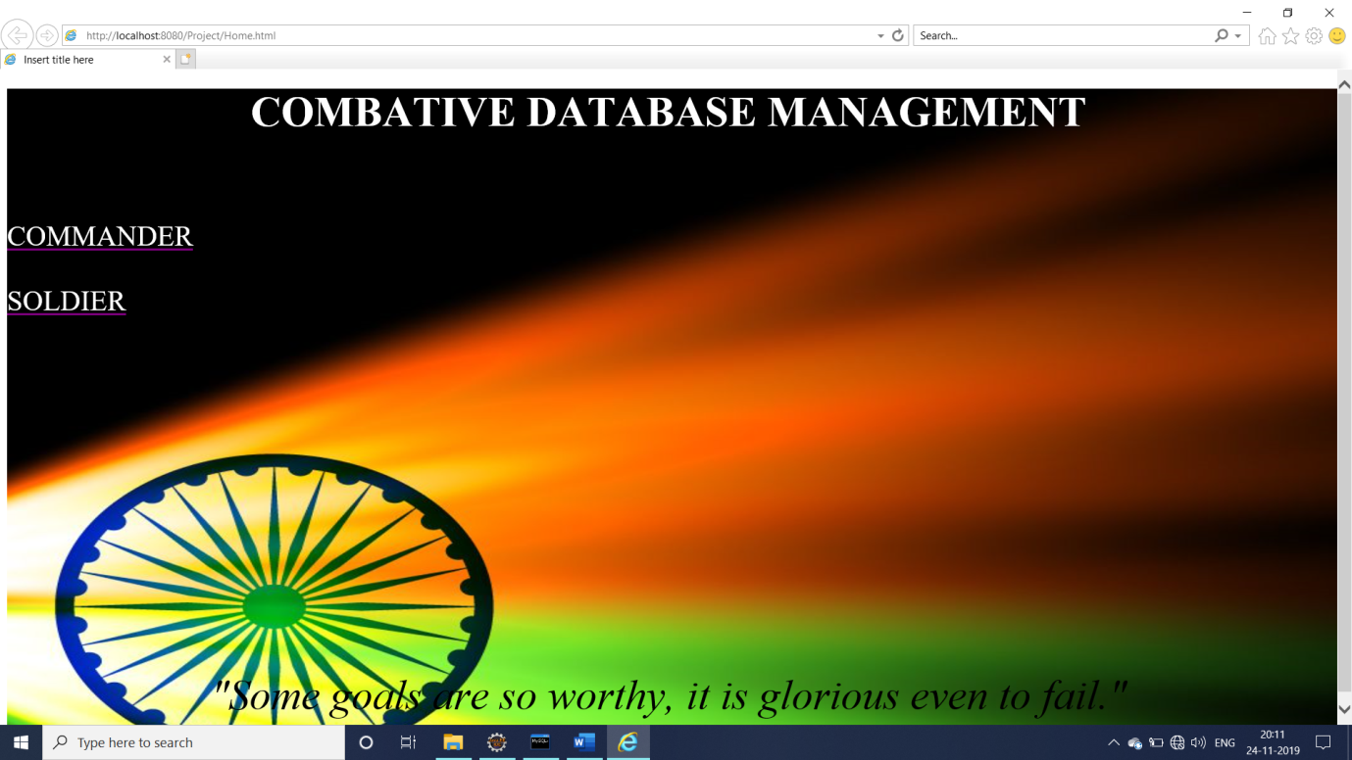

Fig -5.7: Home page

1. COMMANDER REGISTRATION

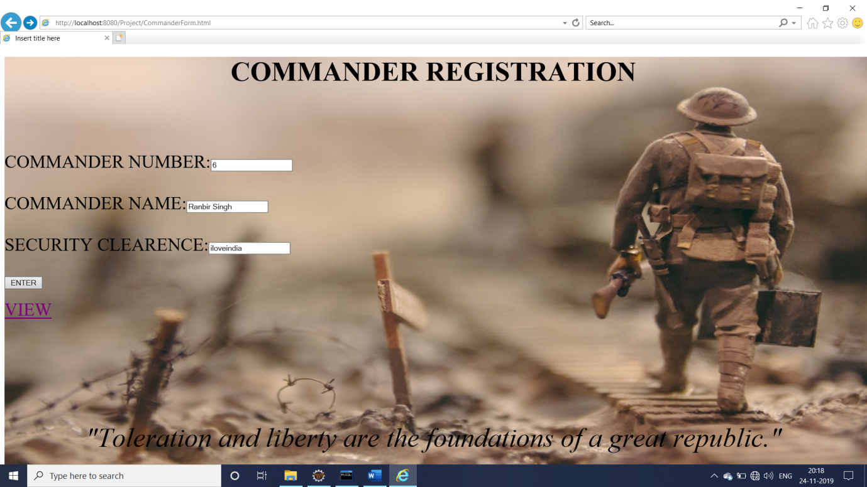

Fig-5.8: Commander Registration

1. DIVISION REGISTRATION

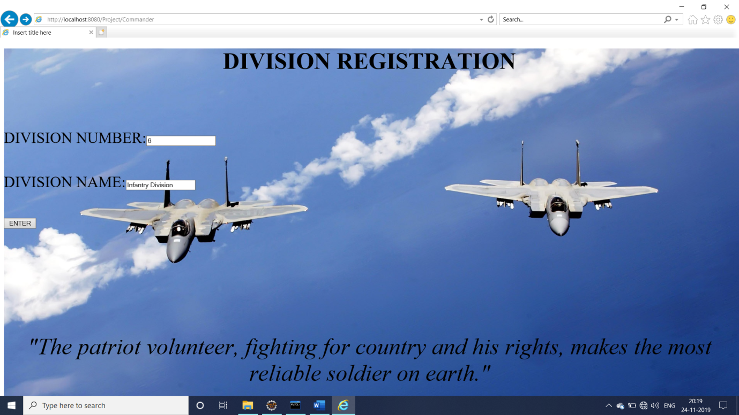

Fig-5.9:Division Registration

1. BARRACKS REGISTRATION

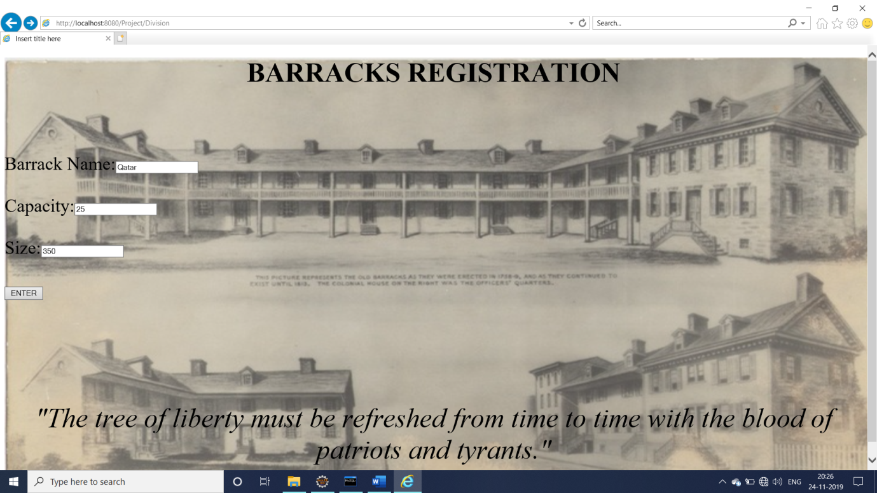

Fig-5.10: Barracks Registration

1. EQUIPMENTS REGISTRATION

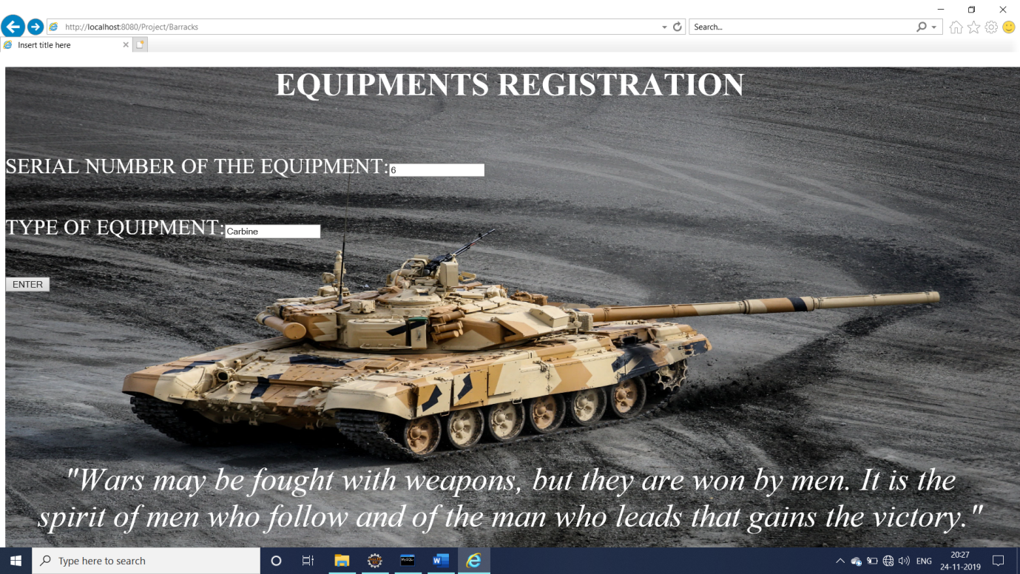

Fig-5.11:Equipment Registration

1. SOLDIER REGISTRATION



Fig-5.12:Soldier Registration

1. REGISTRATION PAGE

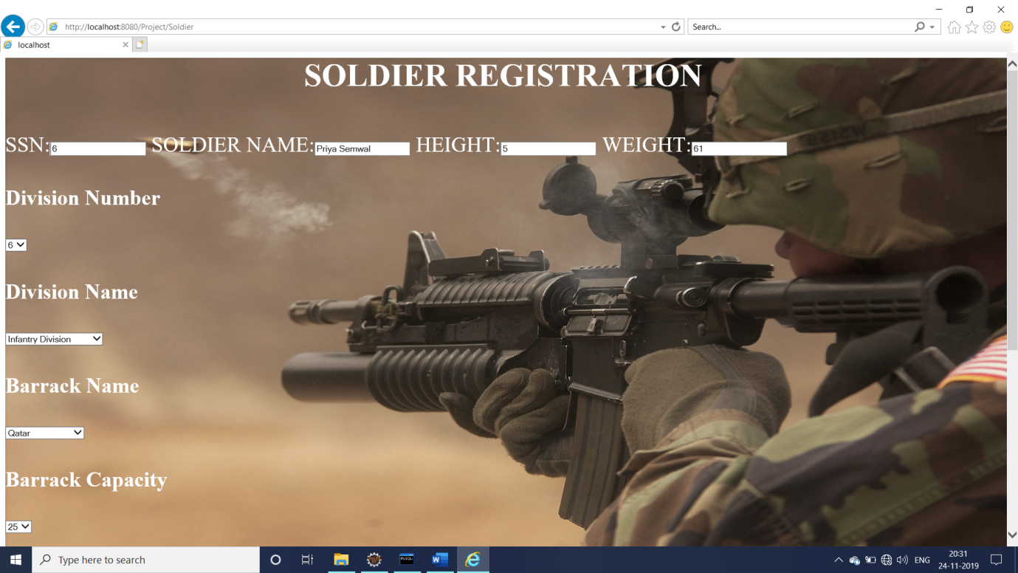

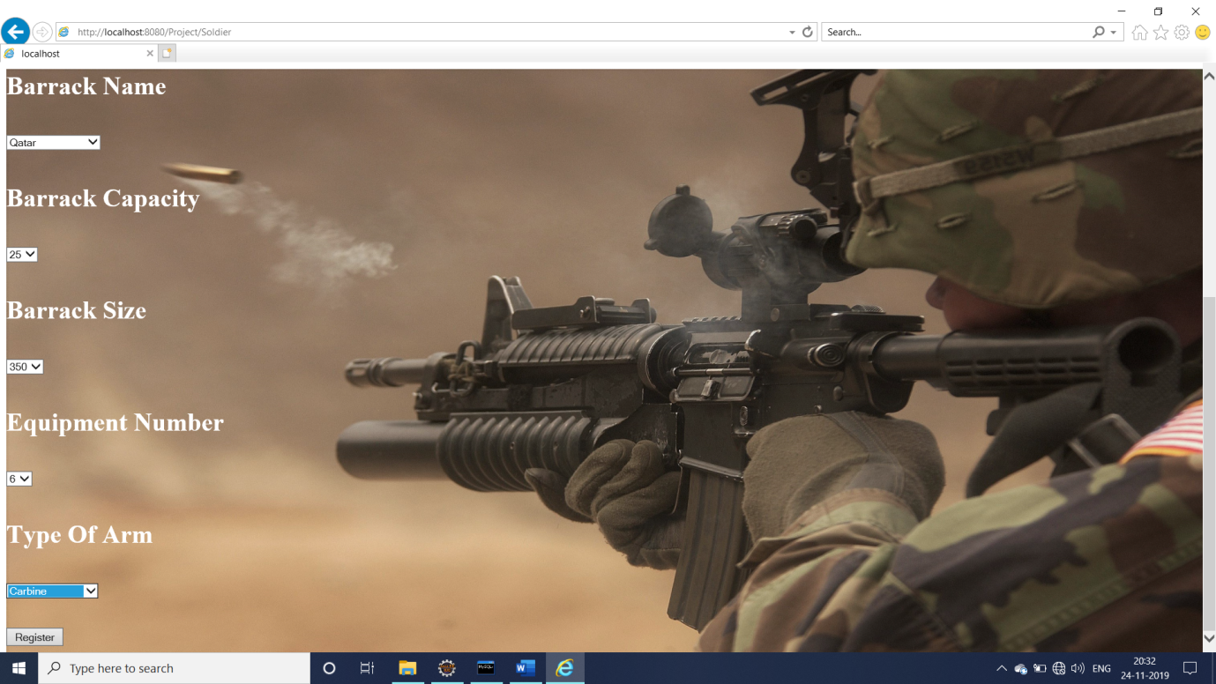

Fig-5.13:Registration Page

1. SUCCESS PAGE



Fig-5.14:Success Page

1. VISION

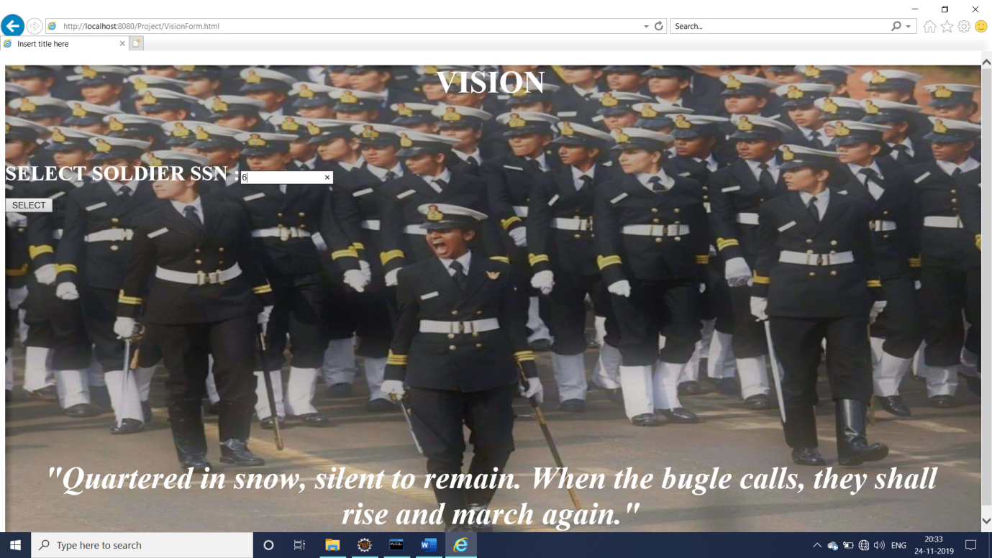

Fig-5.15:Vision Page

1. SOLDIER DETAILS

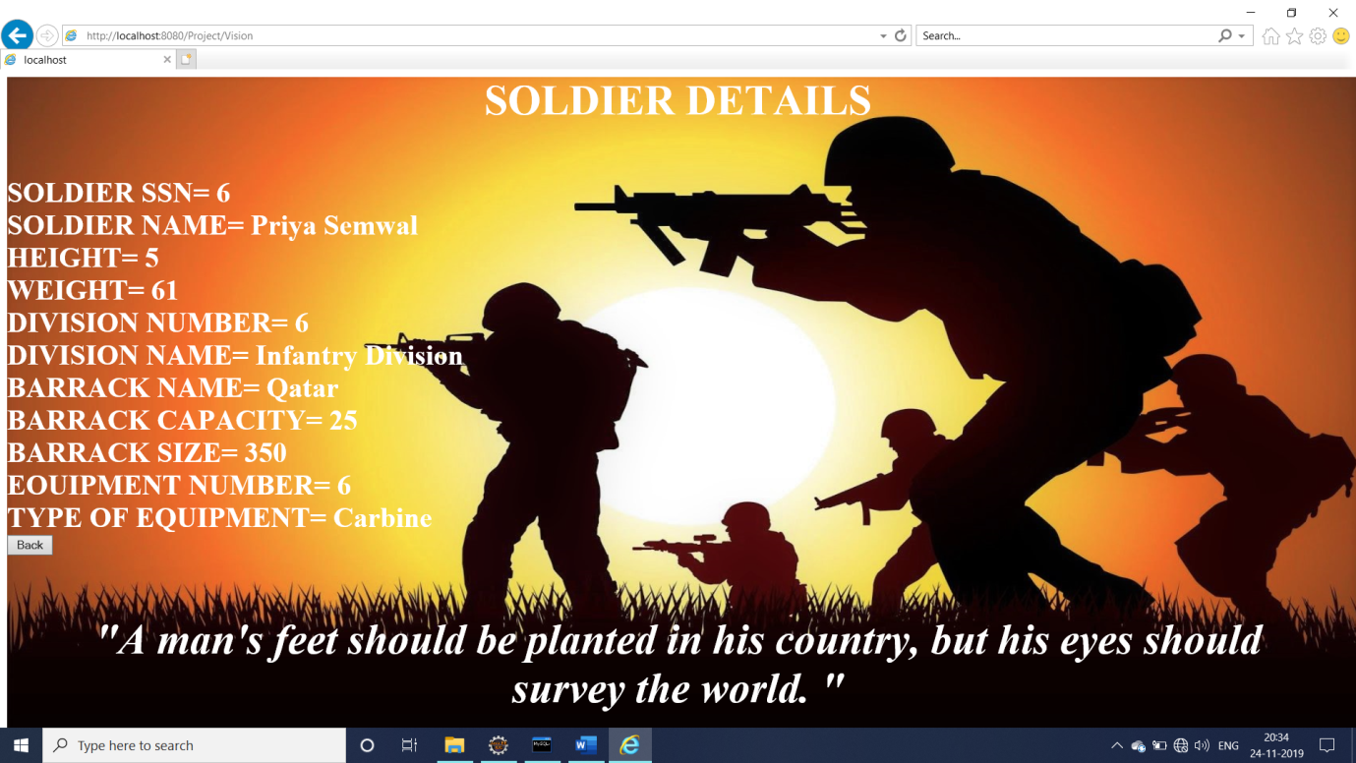

Fig-5.16:Soldier Details

**CONCLUSION**

To conclude, the system is designed to be a useful replacement to the traditional manual record entry that has prevailed. It provides a user with a Intuitive user interface which makes it easy for us to go about the daily job without engaging trivialities like maintaining a record book or updating the columns.

This project achieves the important goal for centralizing all transactions, thus making it easy for the armed forces to keep records.

From a proper analysis of positive points and constraints on the project, it can be concluded that the application makes entire process online. It is highly efficient UI based component which meets all user requirements.

**BIBLIOGRAPHY**

1)      J2EE: The Complete Reference By James Keogh

2)      [www.w3scholls.com](http://www.w3scholls.com) : link-references about HTML

3)      “Learning-SQL” a reference book by Alan Beaulieu